* Task * @Dizzerry @~Tario @DIZZERRY

Design File:

https://www.figma.com/file/D4YE6r8rnwMPqjhSouU4cP/Week-1-Self-Practice?type=design&node-id=0%3A1&mode=design&t=RNyEVyQeq8tLx8E8-1

There are two frames, one for Enu and another for Tario

Todo:

Create a new project,

initialize git (git init)

initialize new npm project (npm init)

install bootstrap (npm install bootstrap)

Copy and paste components from the following pages then paste

to give exactly what I designed. Hint (use inspect element on your browser to copy the sections you need)

https://getbootstrap.com/docs/5.3/examples/

https://getbootstrap.com/docs/5.3/examples/headers/

https://getbootstrap.com/docs/5.3/examples/footers/

https://getbootstrap.com/docs/5.3/examples/album/

https://getbootstrap.com/docs/5.3/examples/carousel/

https://getbootstrap.com/docs/5.3/examples/cover/

https://getbootstrap.com/docs/5.3/examples/pricing/

https://getbootstrap.com/docs/5.3/examples/jumbotrons/

Mode of submission

Create a github repository

push all changes to the github repository

share the github repository with the completed work on Saturday Morning 17th August.

**Expected result.**

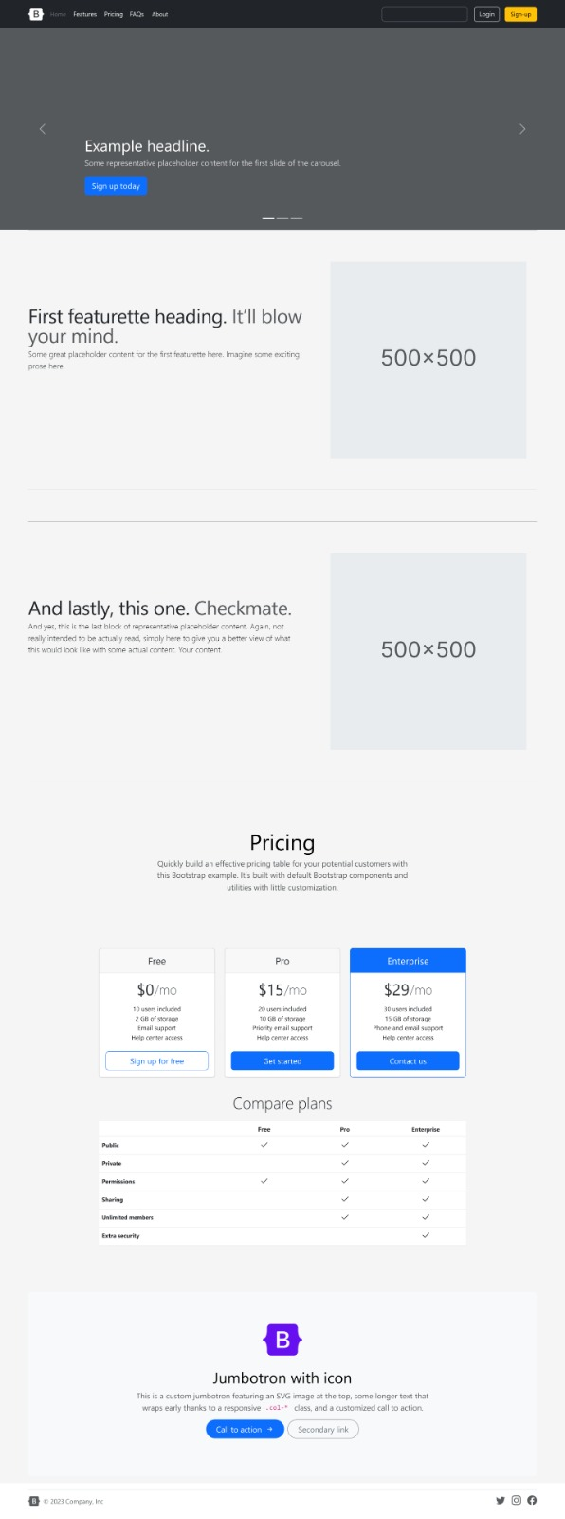

Good luck